**Working with the DOM (Browser HTML Code) in JavaScript**

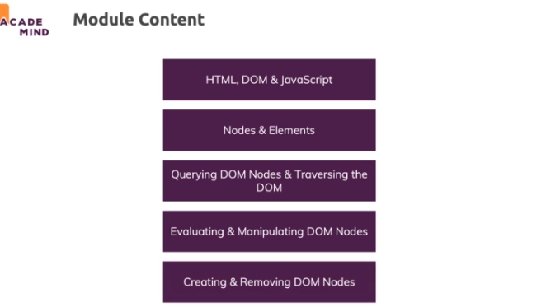

**What's the "DOM"?**

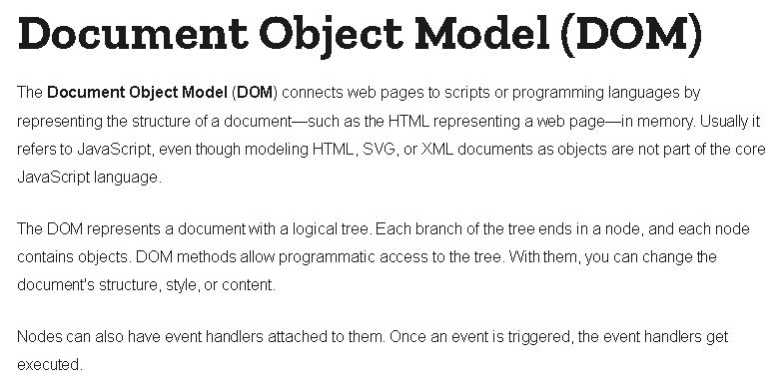

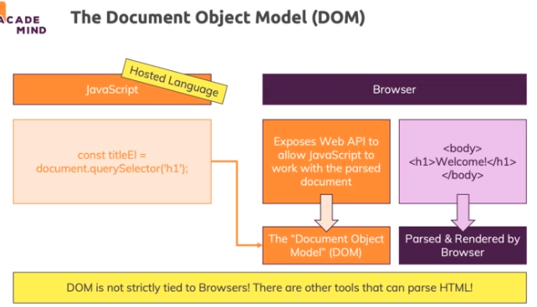

**Document and Window Object**

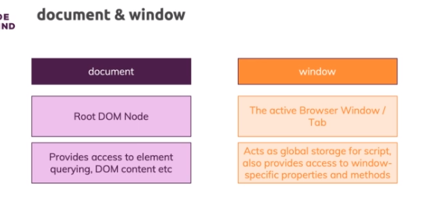

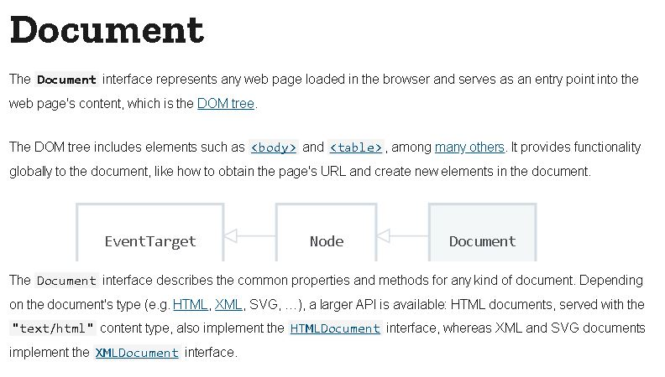

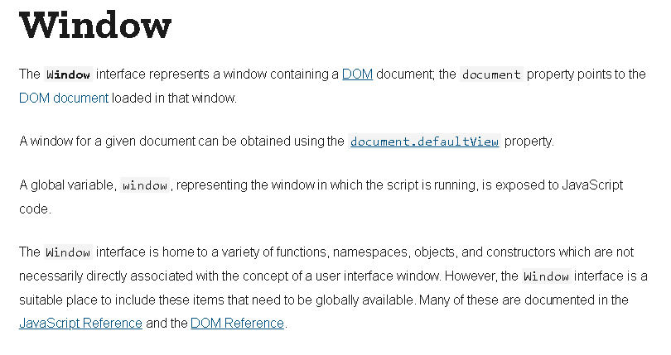

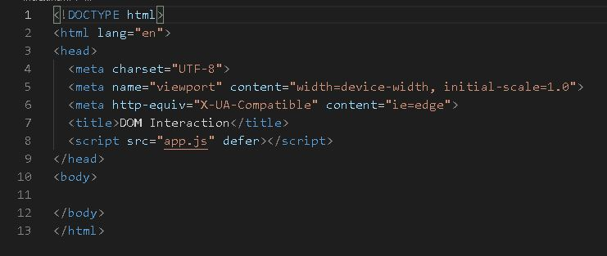

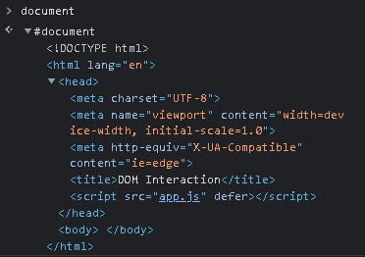

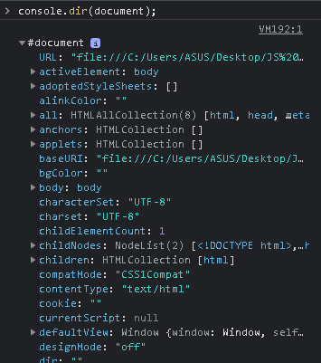

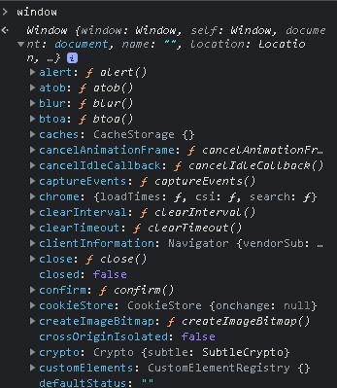

**Understanding the DOM and how it's created**

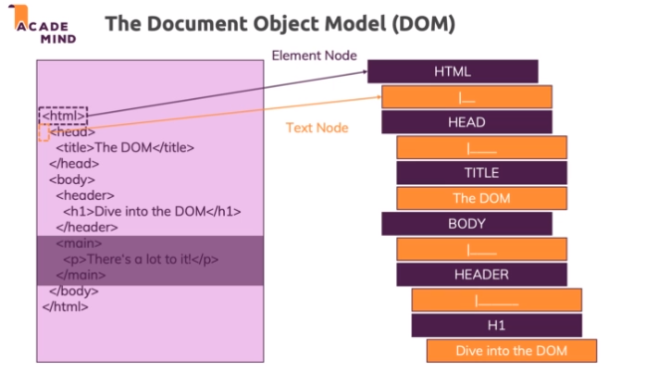

**Querying the DOM Overview**

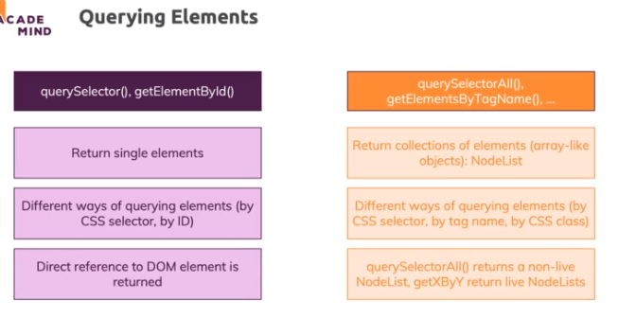

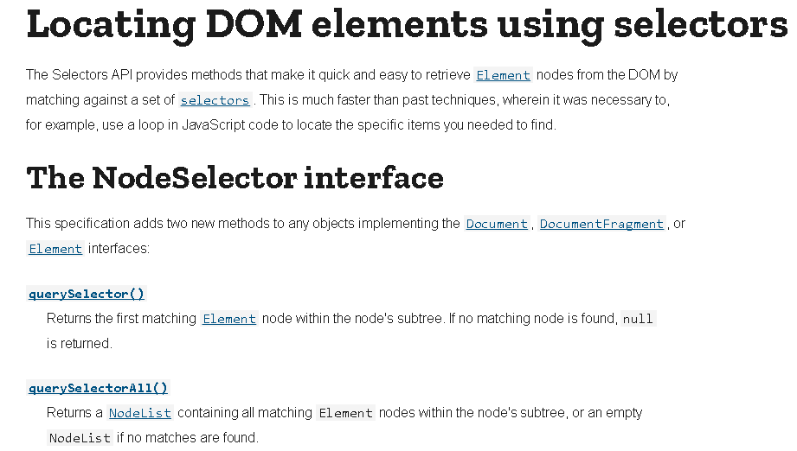

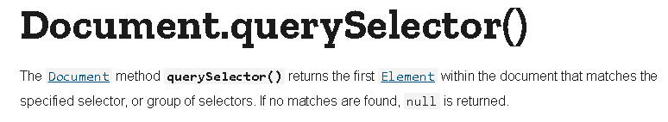

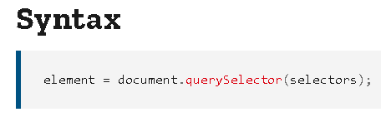

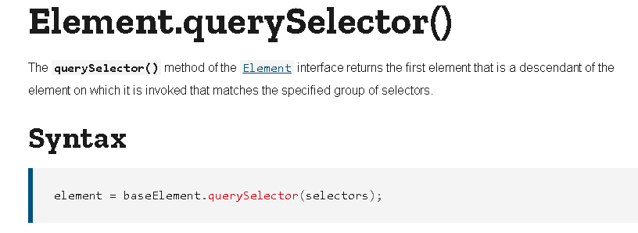

**Nodes & Elements**

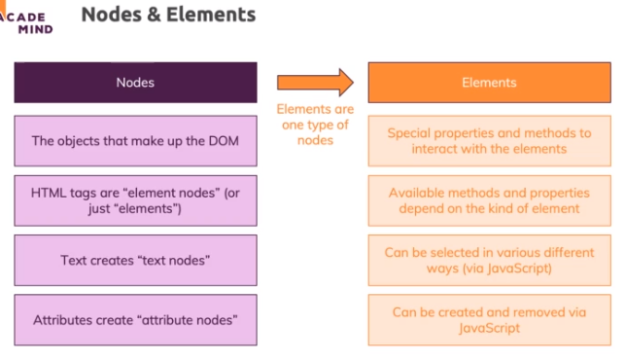

**Selecting Elements in the DOM**

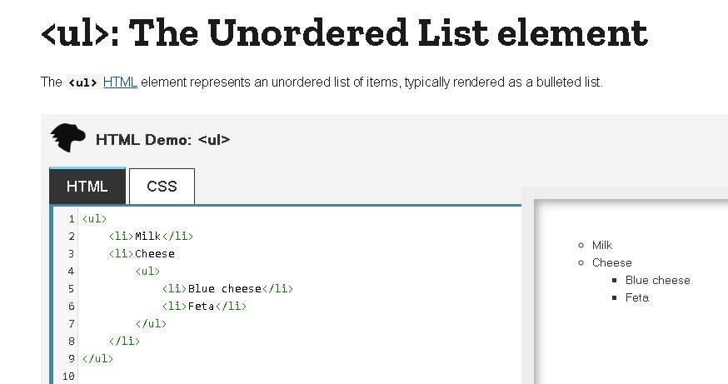

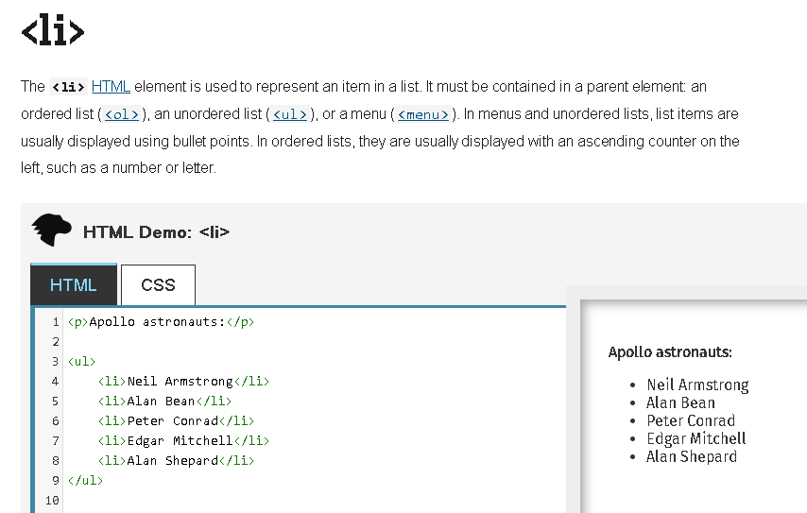

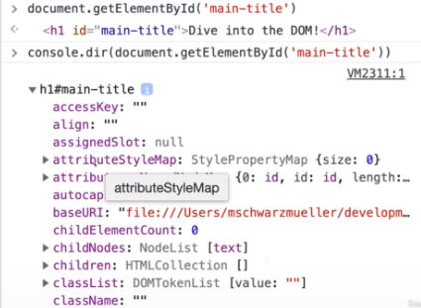

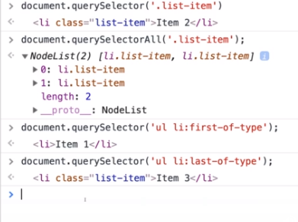

**Exploring and Changing DOM Properties**

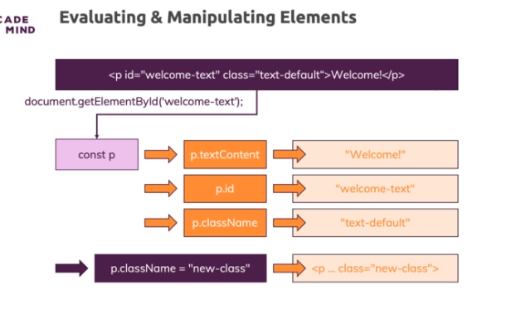

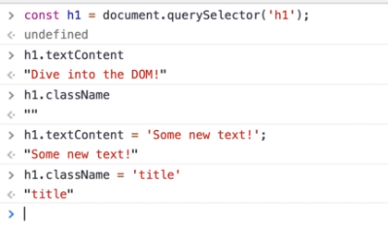

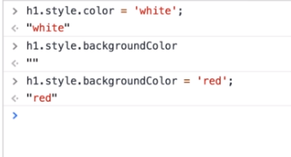

**Attributes vs Properties**

* what you write in the HTML code is named an attribute, what you add on the HTML tag, that's an attribute of that tag
* What the browser does with these attributes is it creates such a DOM object based on the tag name, input in that case and preconfigures it and preconfigures some of its properties based on these attributes
* The property is a value stored in the object that's created based on your HTML code

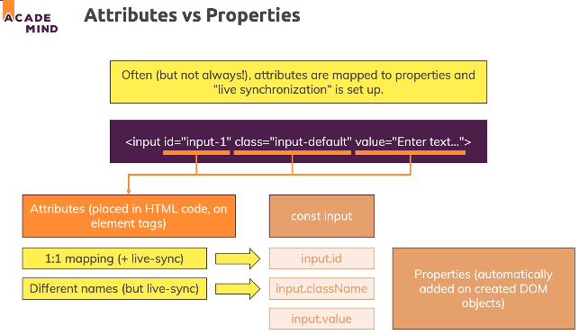

**Selecting Multiple Elements**

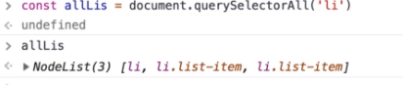

**Traversing the DOM - Overview**

* It means that once you selected one element, one node therefore, you might be interested in diving into all of its child nodes
* so rather than manually selecting every element you might be interested in with query selector or so on,
* you could take an element which you already did select and then move to its children or its siblings

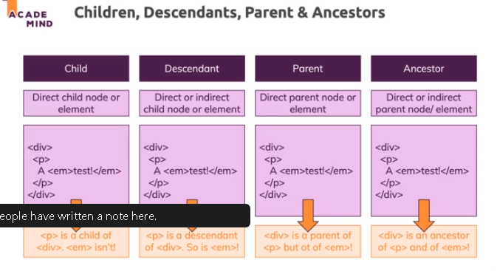

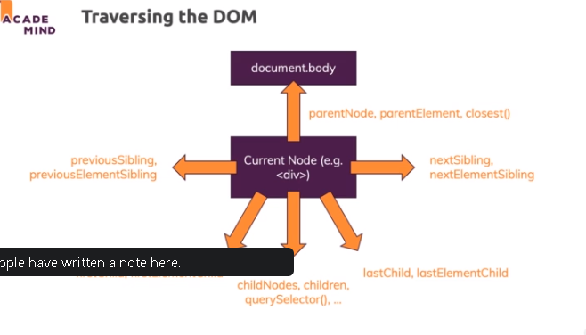

**Traversing Child Nodes**

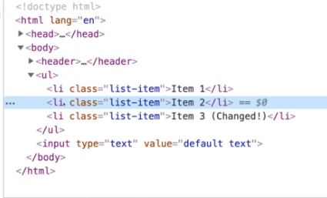

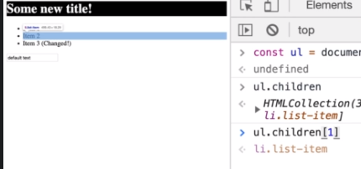

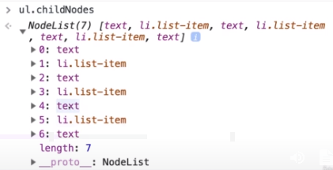

**Using parentNode & parentElement**

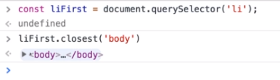

* we can use the closest method and the closest method takes a CSS selector just like query selector

**Selecting Sibling Elements**

* the header is a sibling of the unordered list, it's on the same level as unordered list. It's not a parent or an ancestor

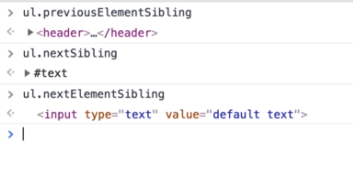

**Styling DOM Elements**

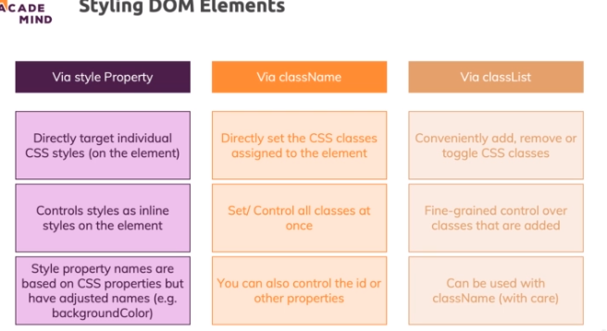

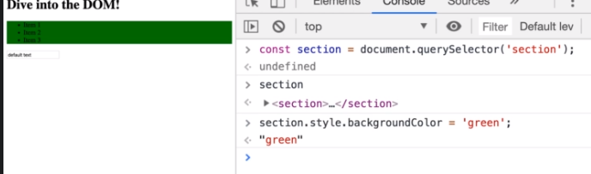

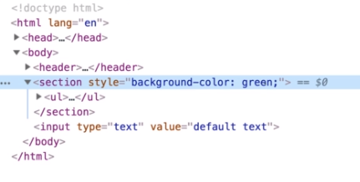

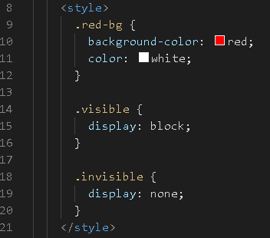

**Creating Elements with JS**

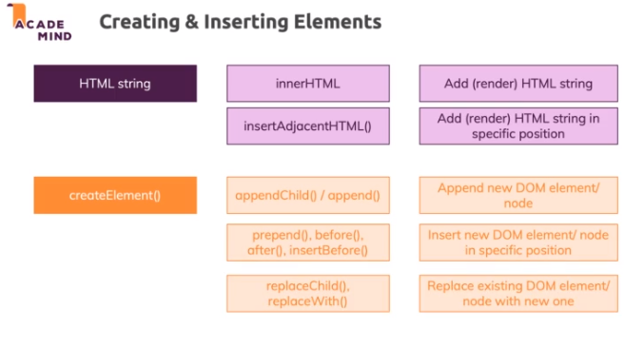

**Adding Elements via HTML in Code**

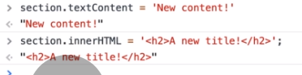

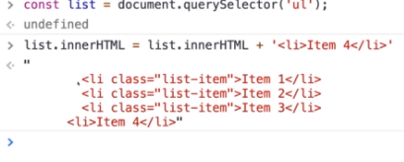

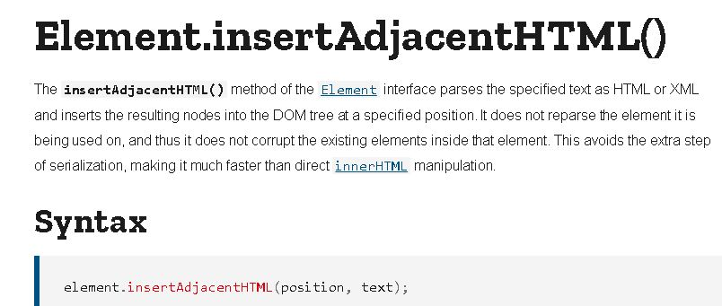

**Adding Elements via createElement()**

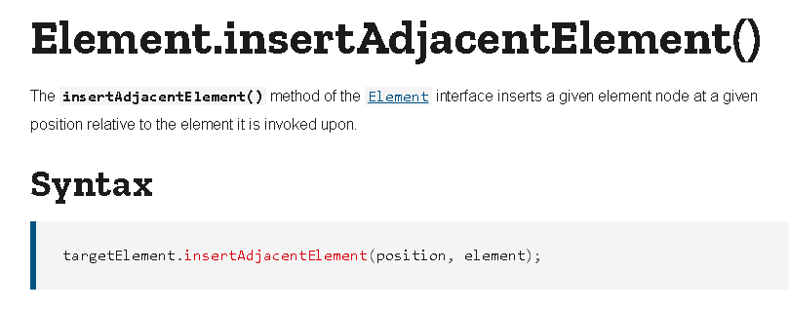

https://paper-attachments.dropbox.com/s_89F90588166036F843AEF301E2C8C80D4D907C7BF2359BCEB6D706F4ECAAE12D_1632556211226_screenshot-www.udemy.com-2021-09-25-13-20-06-468.png

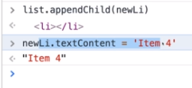

**Inserting DOM Elements**

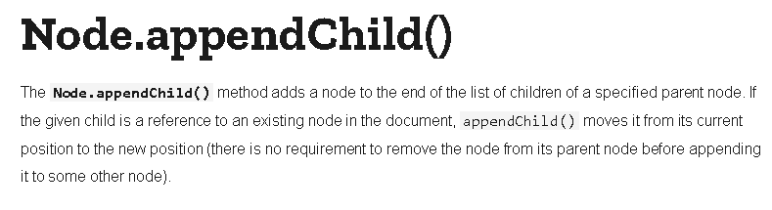

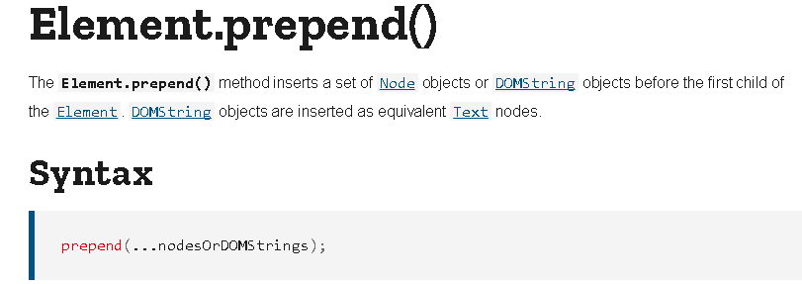

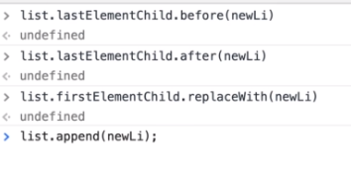

**Cloning DOM Nodes**

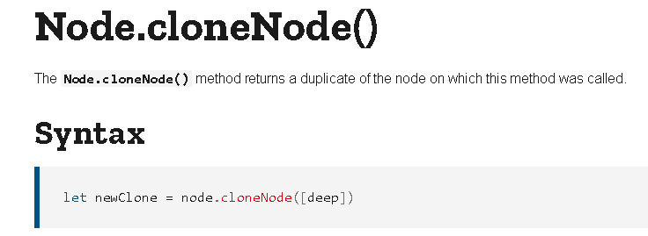

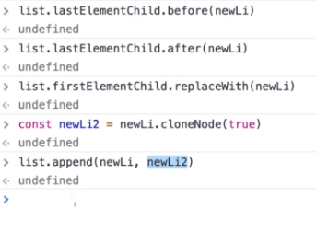

**Live Node Lists vs Static Node Lists**

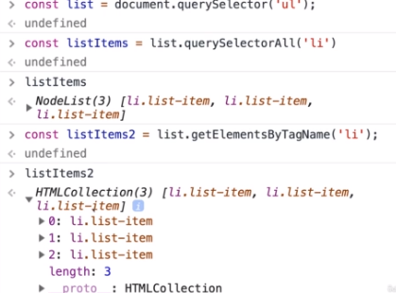

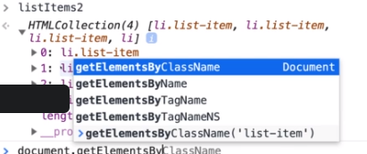

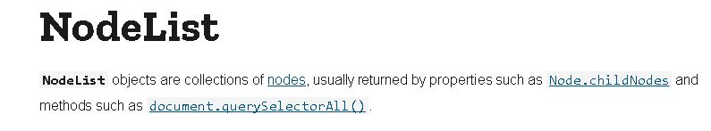

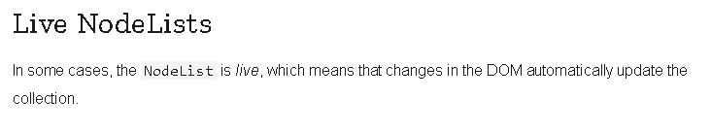

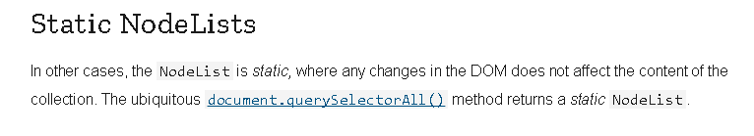

**Removing Elements**

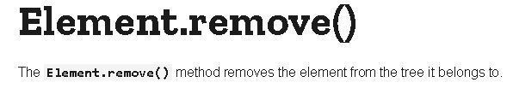

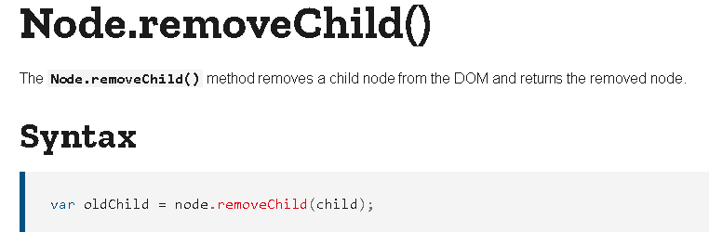

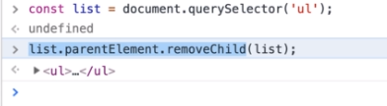

**Insertion & Removal Method Summary**

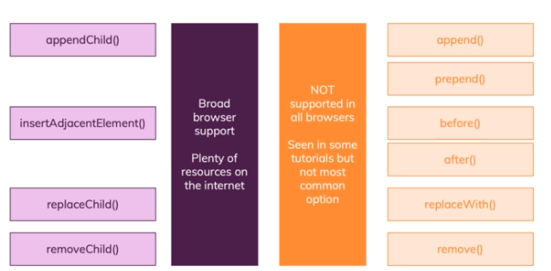

**Selecting the Modal and "Add" Button**

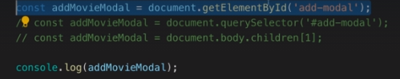

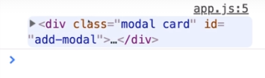

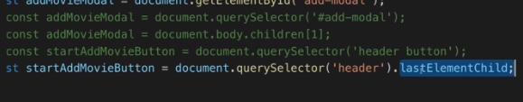

**Opening a Modal by Changing CSS Classes**

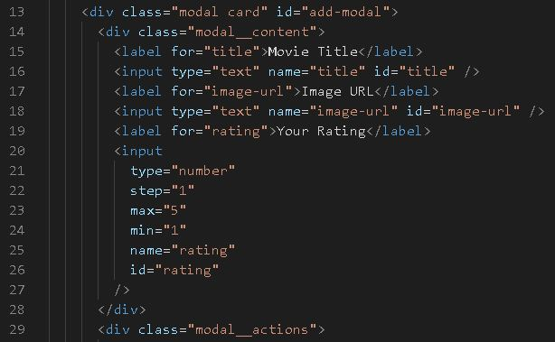

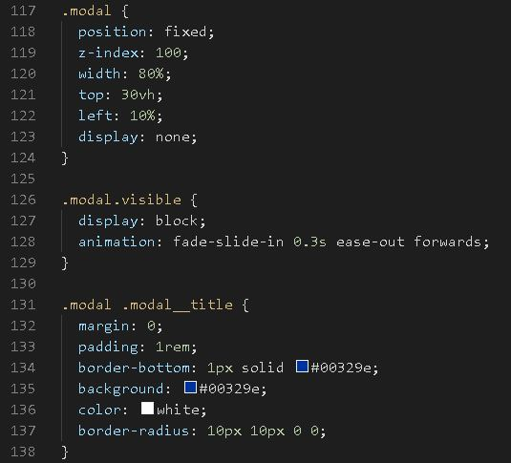

**Controlling the Backdrop**

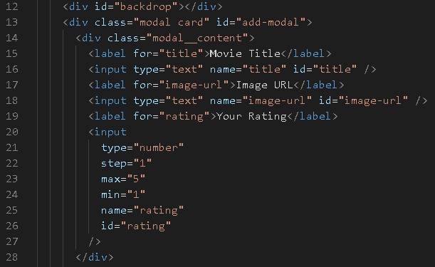

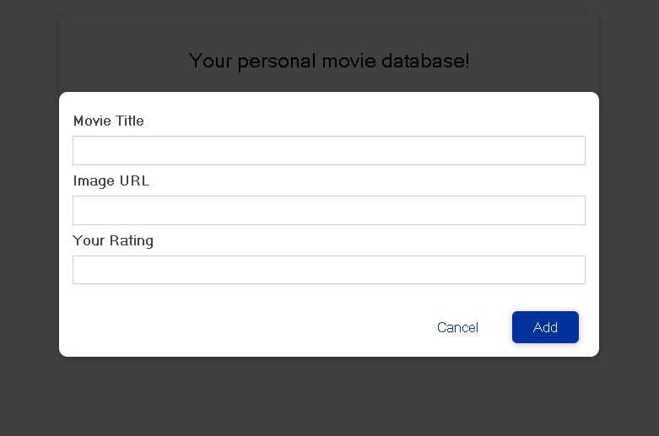

**Fetching and Validating User Input**

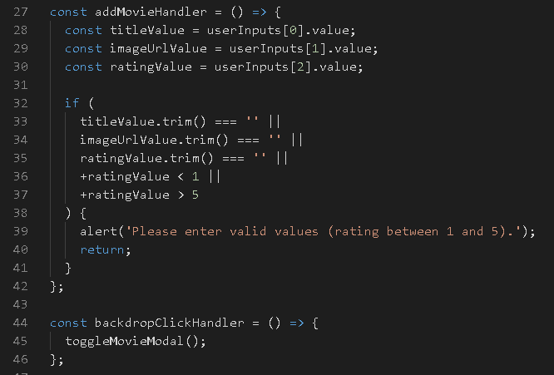

* the .trim method, this will remove excess whitespace at the beginning and at the end of the input so that if you enter something like this which essentially is an empty value but technically is not an empty string

**Creating a Movie in JavaScript & Clearing the Input**

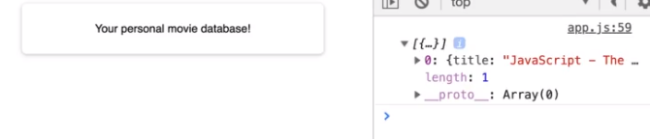

**Rendering Movie Items on the Screen**

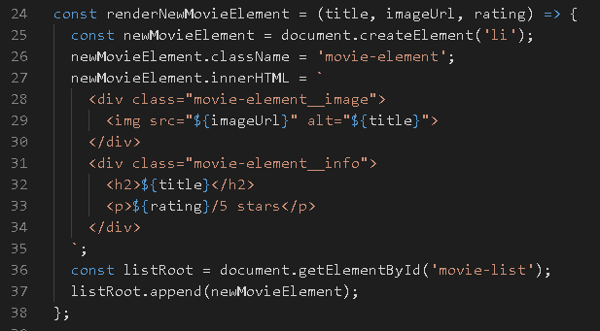

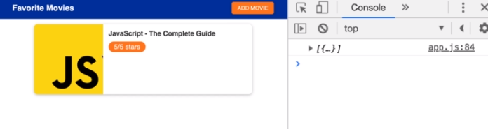

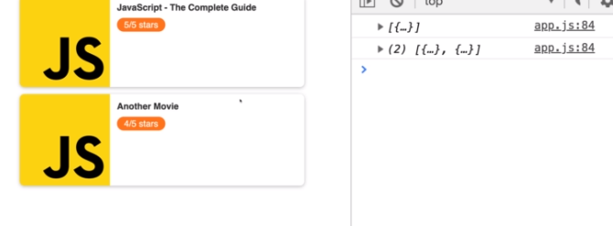

**Deleting Movie Elements**

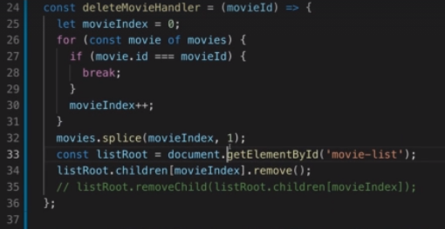

**Showing & Hiding the "Are you sure?" Dialog**

